**NCLAUNCH Simulation**

**Procedure**

* Create a folder on the desktop and copy the Examples of Verilog files into.
* Open up the folder and run the terminal as shown below:

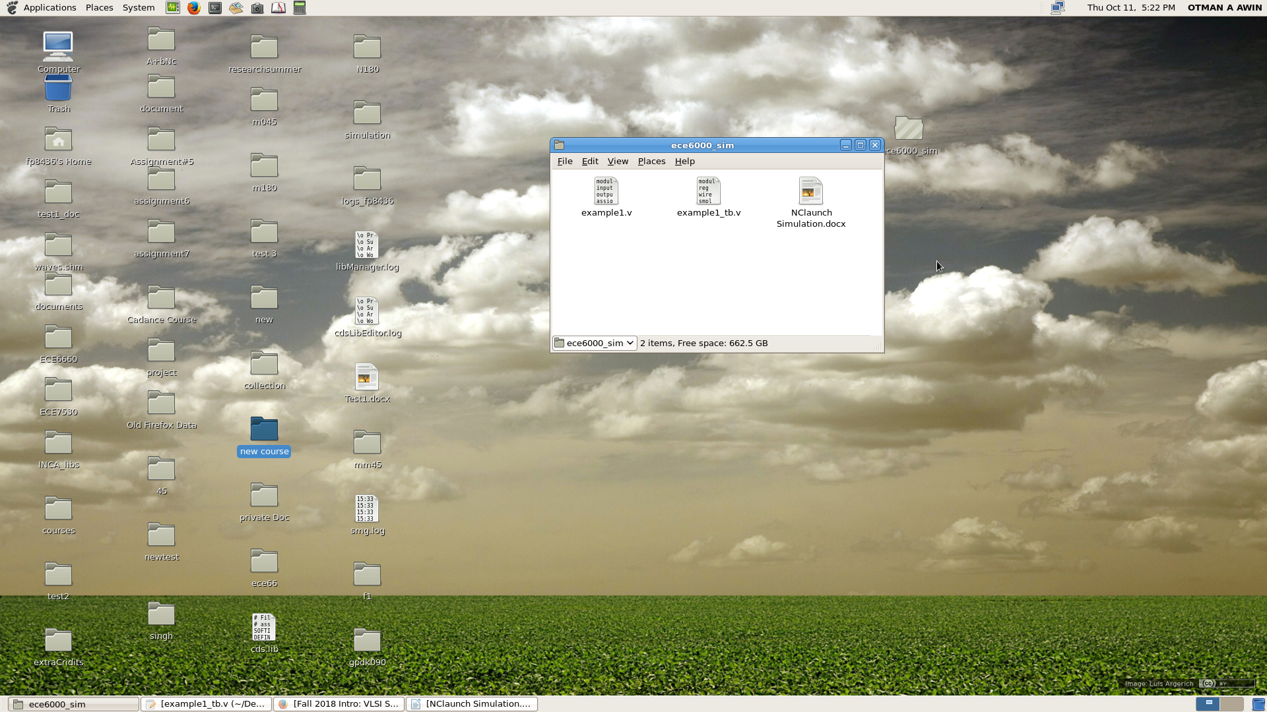

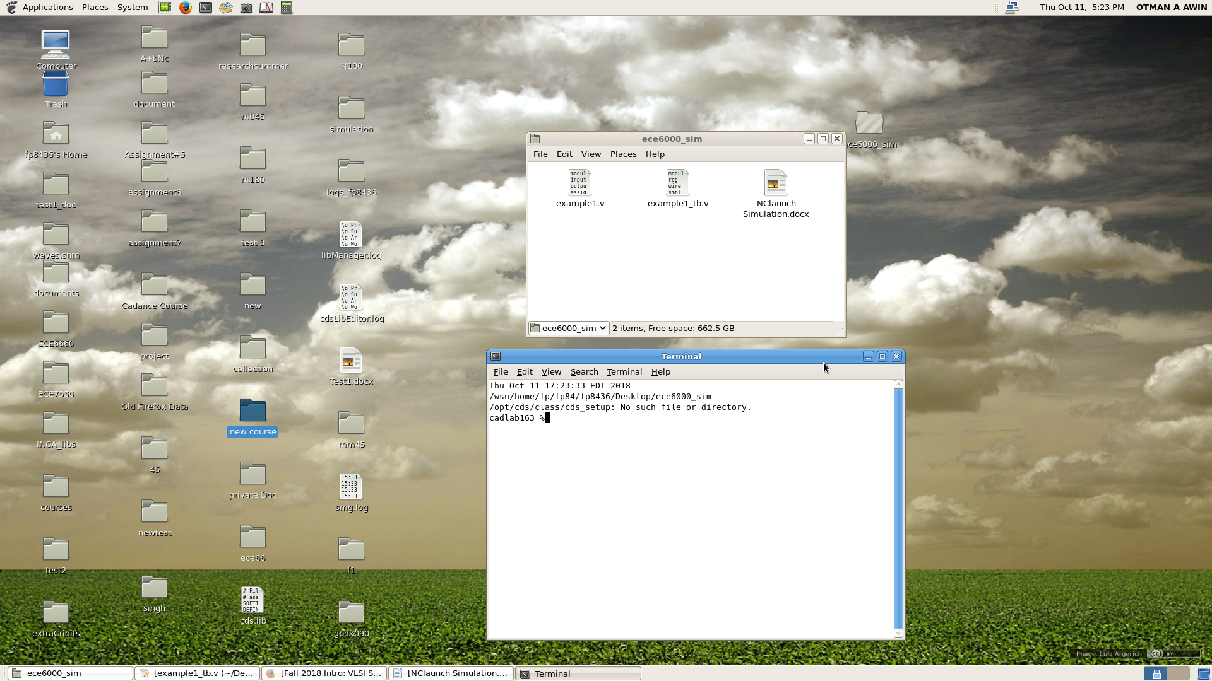

* At prompt of terminal write nclaunch and press enter the foolowing program will show up

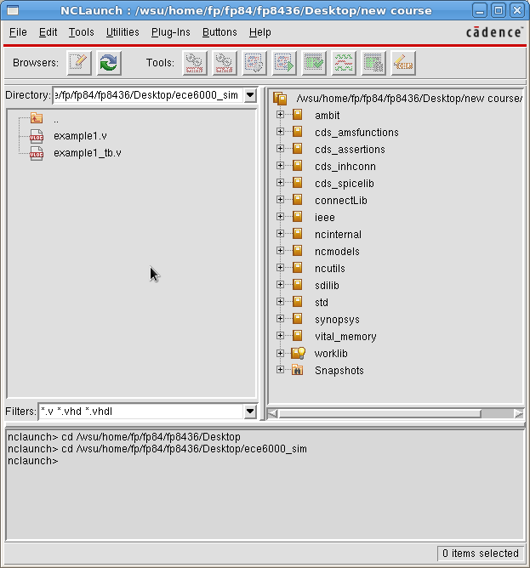

* Double Click on example1.v and example1_tb.v respectively and check there are no errors showed up.

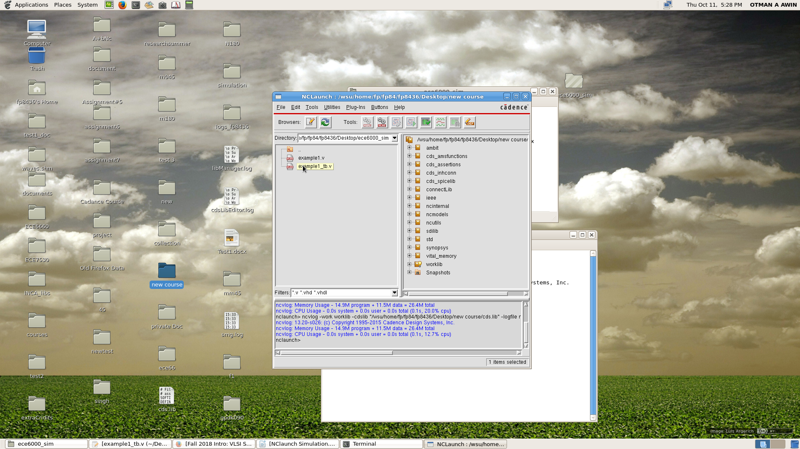

* Go to the other panel where the folders are there, and click on the plus beside worklib folder two items which are smpl_circuit and smpl_circuit_tb then for each item make rigth click on it and take NCElab item from pop menu and click ok .

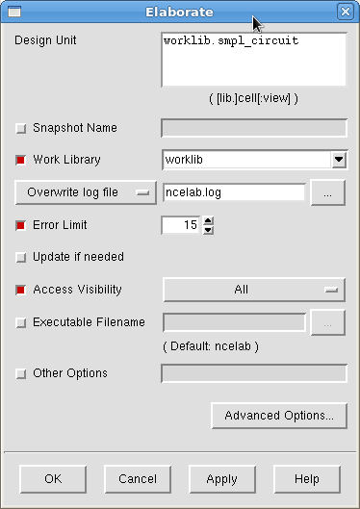

* Now Go to Snapshots folder and click the plus worklib.smpl_circuit.module worklib.smpl_circuit_tb.module are pop up. Rigth click on worklib.smpl_circuit_tb.module and choose NCSim and click ok

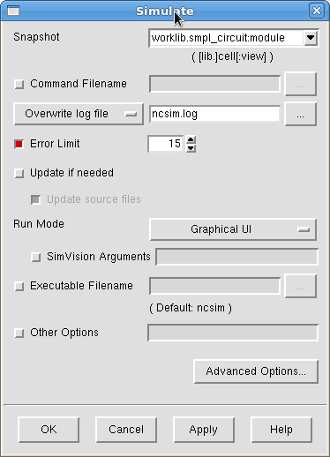

* New window will show up

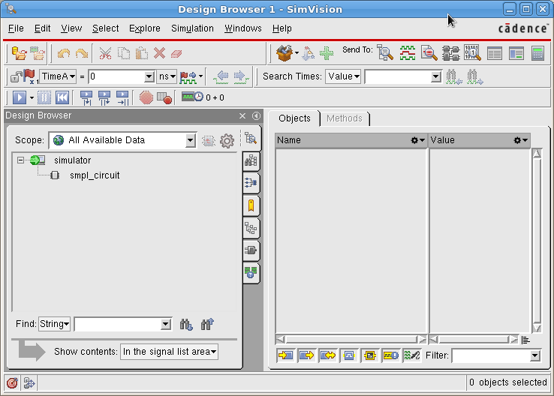

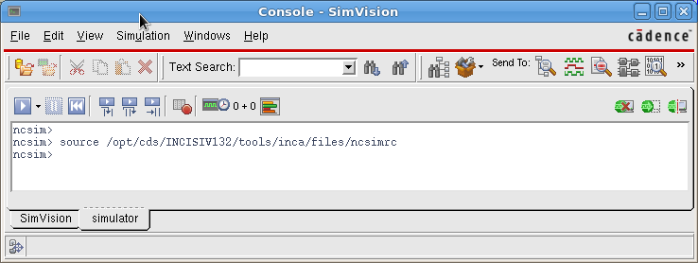

* Click smpl_circuit on object panel the inputs and outputs are shown up. Then click on Select menu and click on Signals item

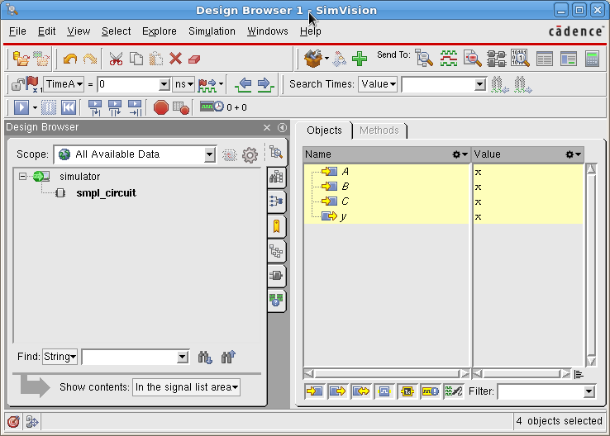

* Click on the Icon Send to target and the simulation window will be opend

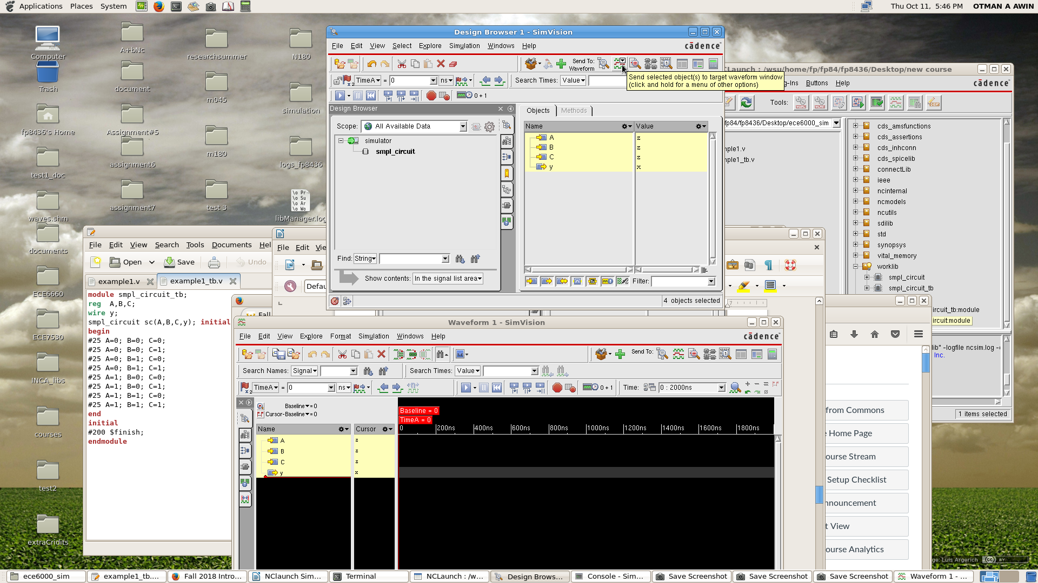

* Finally, click on start simulation icon and the simulation will start .

